UNIVERSITY OF RWANDA
COMPUTER ENGINEERING WEB DESIGN

REG NUMBER: 225056635

Project Technical Report – UMURANGA Platform

Chapter 1. Introduction
1.1 Historical Background
In many Rwandan communities, finding trustworthy service providers such as plumbers, electricians, carpenters, and cleaners is a challenge. At the same time, skilled workers often struggle to reach potential clients. UMURANGA was conceived as a digital solution to bridge this gap by leveraging modern web technologies to connect service seekers with providers in a centralized, reliable platform.
1.2 Problem Statement
- Lack of a unified trustworthy system for connecting clients with skilled workers.
- Difficulty for workers to showcase their skills and build credibility.
- Limited transparency and trust in informal hiring processes.
1.3 Objectives
- To design and implement a web-based platform that connects service seekers with skilled workers.
- To enable workers to create professional profiles highlighting their skills and experience.
- To integrate a review and rating system that promotes accountability and trust.
- To provide location-based search for efficient service discovery.
1.4 Expected Outcomes
- A functional platform where users can register, search, and hire workers.
- Workers gain visibility and employment opportunities.
- Clients benefit from verified reviews and transparent hiring.
- Strengthened local economies through improved service accessibility.
1.5 Project Rationale
UMURANGA contributes to reducing unemployment, improving service delivery, and fostering trust between communities and skilled professionals. It empowers workers while simplifying life for clients.
Chapter 2. System Analysis and Design
2.1 System Analysis
Intended Users:
- Ordinary Users (service seekers).
- Skilled Workers (service providers).
- Admins (platform managers).
System Partners:
- Local communities.
- Skilled labour associations.
- ICT development initiatives.
2.2 System Design
High-Level Architecture:
- Frontend: HTML, CSS, JavaScript (responsive design).
- Backend: Database for storing users, workers, jobs, reviews, and notifications.
- Integration: Location-based search and notification system.
UI Design:
- Navigation bar with logo and menu.
- Hero section introducing the platform.
- Account pages for profile management.
- Signup/login forms with validation.
Database Design (ERD):
- Users (user_id, name, email, location, password).
- Workers (worker_id, name, skills, experience, location).
- Jobs (job_id, user_id, worker_id, service_type, status, date).
- Reviews (review_id, job_id, rating, comment).
- Notifications (notification_id, user_id, worker_id, type, status).
- Admins (admin_id, name, role).
- Categories (category_id, service_type).
Chapter 3. Implementation
3.1 Introduction
The UMURANGA system was implemented using HTML, CSS, and JavaScript for the frontend, with a structured database design for backend operations.
3.2 Screenshots & Discussion
- Homepage: service categories (plumber, mechanic, electrician, etc.), testimonials, quick links.
The homepage is designed to immediately communicate the platform’s purpose. The hire section builds trust with a welcoming message, while service categories use images to make navigation intuitive. Testimonials provide social proof, and quick links allow users to access core features quickly. This design prioritizes clarity and accessibility.
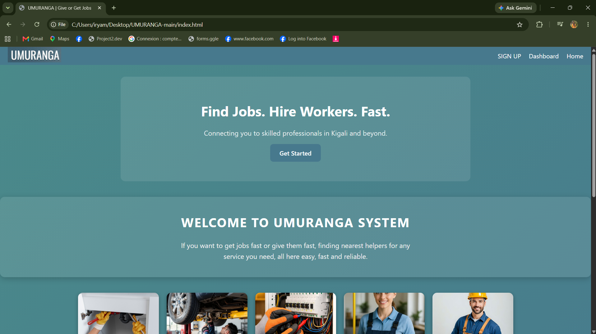

- Signup Page: User registration with password validation.
The signup page ensures secure account creation. Password validation prevents mismatches, improving user experience and security. The design uses a centered signup box with clear labels and buttons, making it beginner-friendly. The hover effects on buttons enhance interactivity.

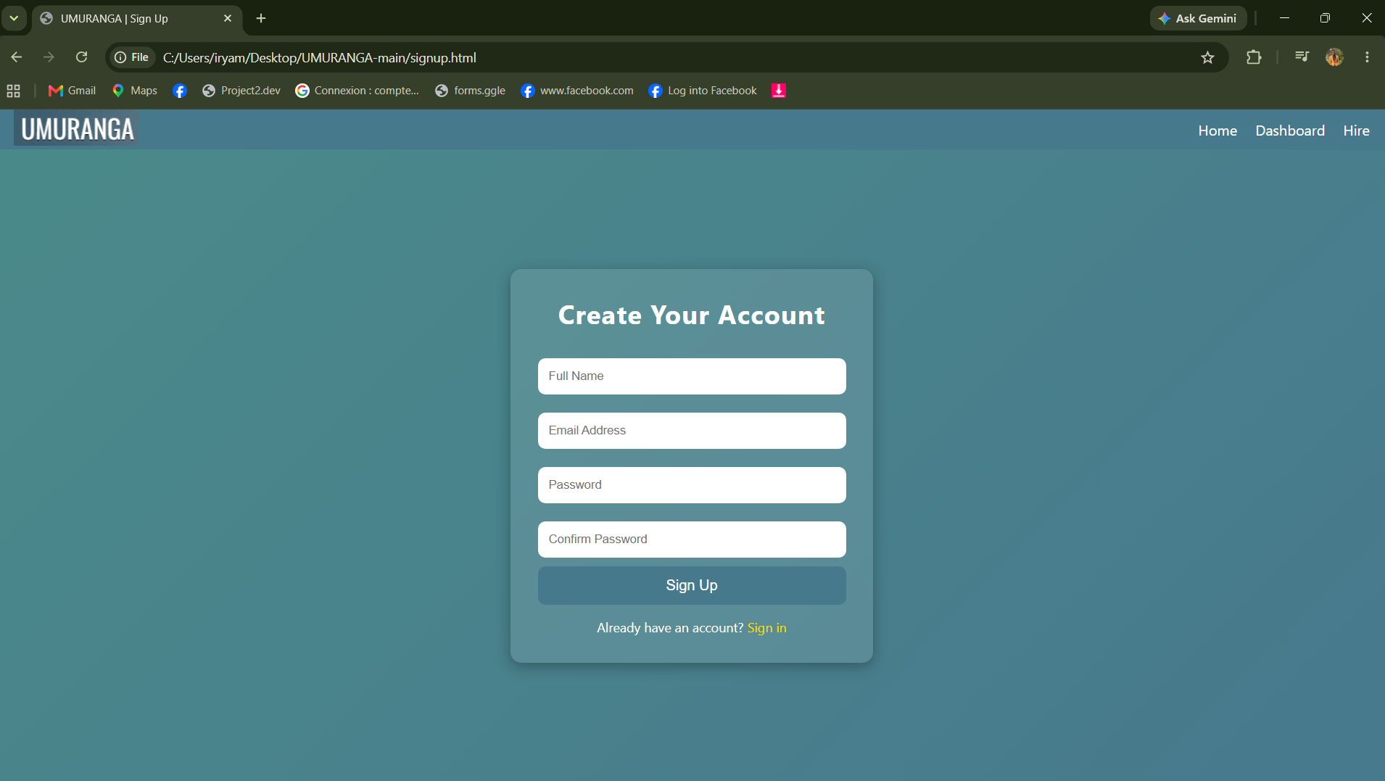
- Account Page: Profile box, settings, light/dark mode toggle.
The account page allows users to manage their profile and preferences. The profile box displays personal details, while account actions (edit, logout) provide control. The settings box organizes options like notifications and privacy. The light mode toggle improves accessibility for different environments.
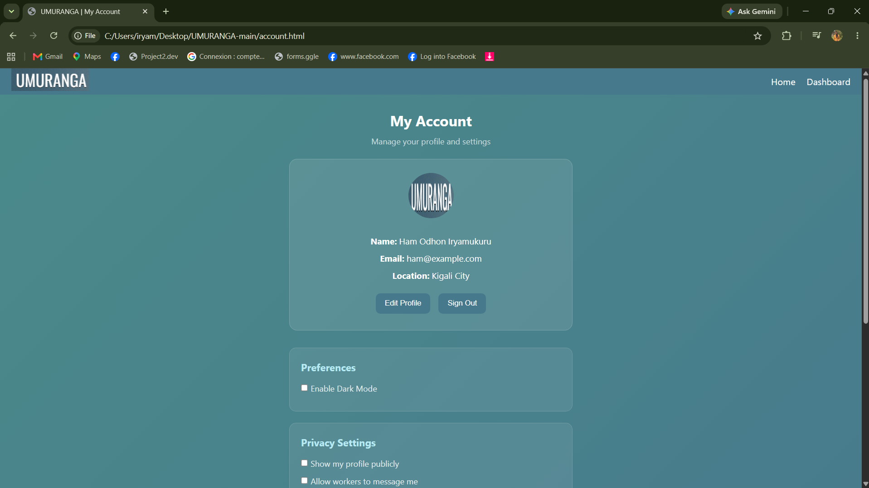
- Navigation: Active link highlighting for better UX
- Logout Feature: Redirects users to homepage after sign-out.
Chapter 4. Conclusion and Recommendations
Conclusion
UMURANGA successfully achieves its objectives by creating a reliable platform for connecting service seekers and providers. The system promotes transparency, accountability, and employment opportunities.
Recommendations
- To Lecturers: Provide more time for practical implementation of advanced features.
- To School: Encourage collaboration with local communities for real-world testing.
- To Partners: Support scaling of the platform to reach more users.
- To Users: Provide training on how to use the platform effectively.
- To Beneficiaries: Embrace the tool as a modern solution for service accessibility.
Appendix
- ERD
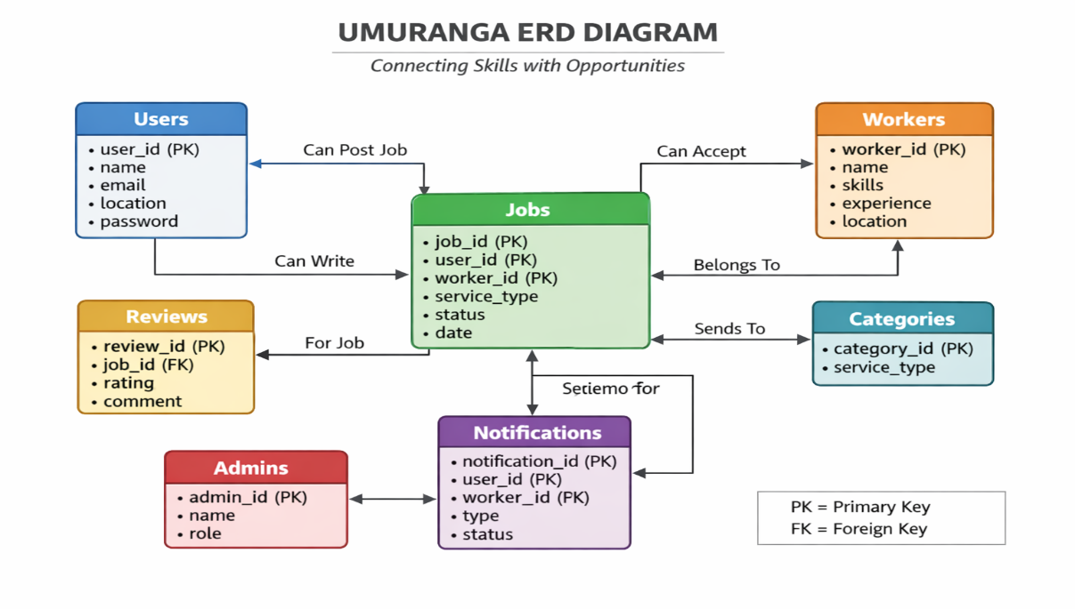
- GitHub repository link: https://github.com/HamOdhon66/UMURANGA

